**1**. How to load test email server

2. Configure SMTP sampler to send email

________________________________________________________________________________

Step 1 : Configuring JavaMail

The JavaMail API provides a platform-independent and protocol-independent framework to build mail and messaging applications. The JavaMail API is available as an optional package for use with the [Java SE platform](http://www.oracle.com/technetwork/java/javase/index.html) and is also included in the [Java EE platform](http://www.oracle.com/technetwork/java/javaee/index.html).

Download JavaMail(javax.mail.jar) from [here.](https://javaee.github.io/javamail/)

Put the jar file in lib folder of JMeter.

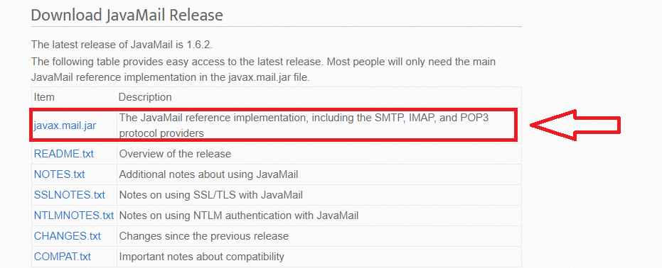

Step 2 :Create Test Plan & Add Thread Group

I have already posted a tutorial on how to add Thread group to a Test Plan. [Click here](https://qaprovider.com/discussion/show/how-to-use-jmeter-http-performance-test/23) to check.(Upto step-3)

Step 3 : Add SMTP sampler

The SMTP Sampler can send mail messages using SMTP/SMTPS protocol. It is possible to set security protocols for the connection (SSL and TLS), as well as user authentication. If a security protocol is used a verification on the server certificate will occur.

To add SMTP sampler [Thread Group->Add->Sampler->SMTP sampler]

Server :Hostname or IP address of the server. See below for use with file protocol. For gmail the servers will be smtp.googlemail.com / smtp.gmail.com

Port :  Port to be used to connect to the server. Defaults are: SMTP=25, SSL=465, StartTLS=587

Connection timeout : Connection timeout value in milliseconds (socket level). Default is infinite timeout.

Read timeout : Read timeout value in milliseconds (socket level). Default is infinite timeout.



Address From : The from address that will appear in the e-mail

Address To : The destination e-mail address (multiple values separated by ";")



Use Auth : Indicates if the SMTP server requires user authentication.(Sender's email id & password)



Use no security features : Indicates that the connection to the SMTP server does not use any security protocol.

Use SSL : Indicates that the connection to the SMTP server must use the SSL protocol.

Use StartTLS : Indicates that the connection to the SMTP server should attempt to start the TLS protocol.

Enforce StartTLS : If the server does not start the TLS protocol the connection will be terminated.



Finally the message subject & message body

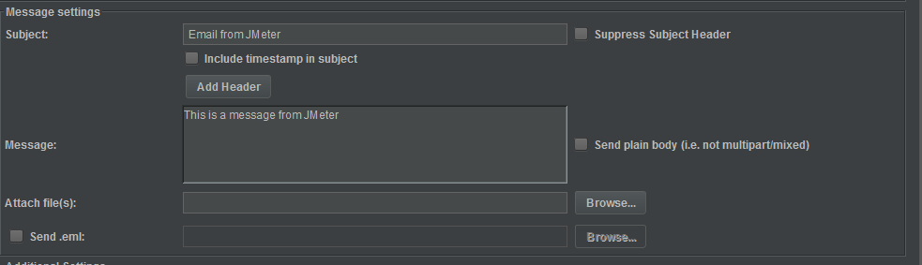

We can also attach files with the message.

Step 4 : Add Listener to validate the test

Just add a simple listener Results Tree to check the result [Thread Group->Add->Listener->View Results Tree] & run the test.

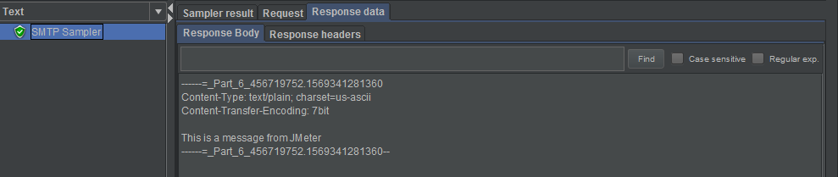

This is the actual validation that we were expecting,

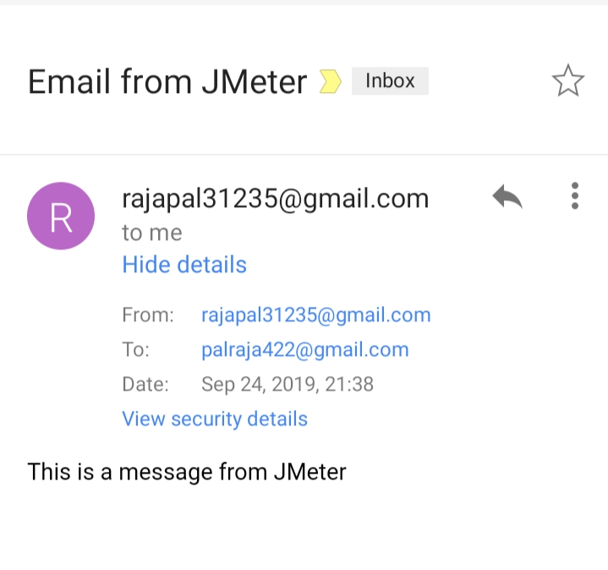

There might be 99% chance of getting an error code 500 & a failed test because Google doesn't allow less secure apps to access authenticated user details.

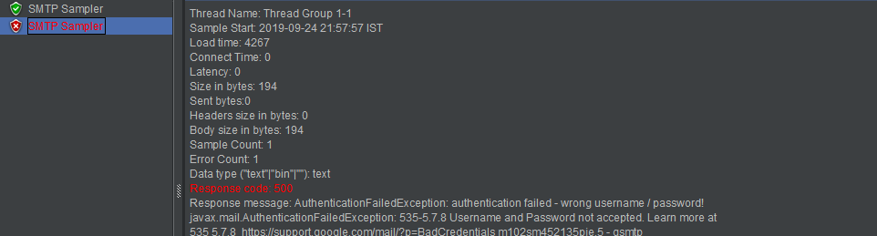

To avoid this, either use a test mail id provided by the organization or go to Google account settings->Security->Allow access to less secure apps to allow JMeter to access to your account.